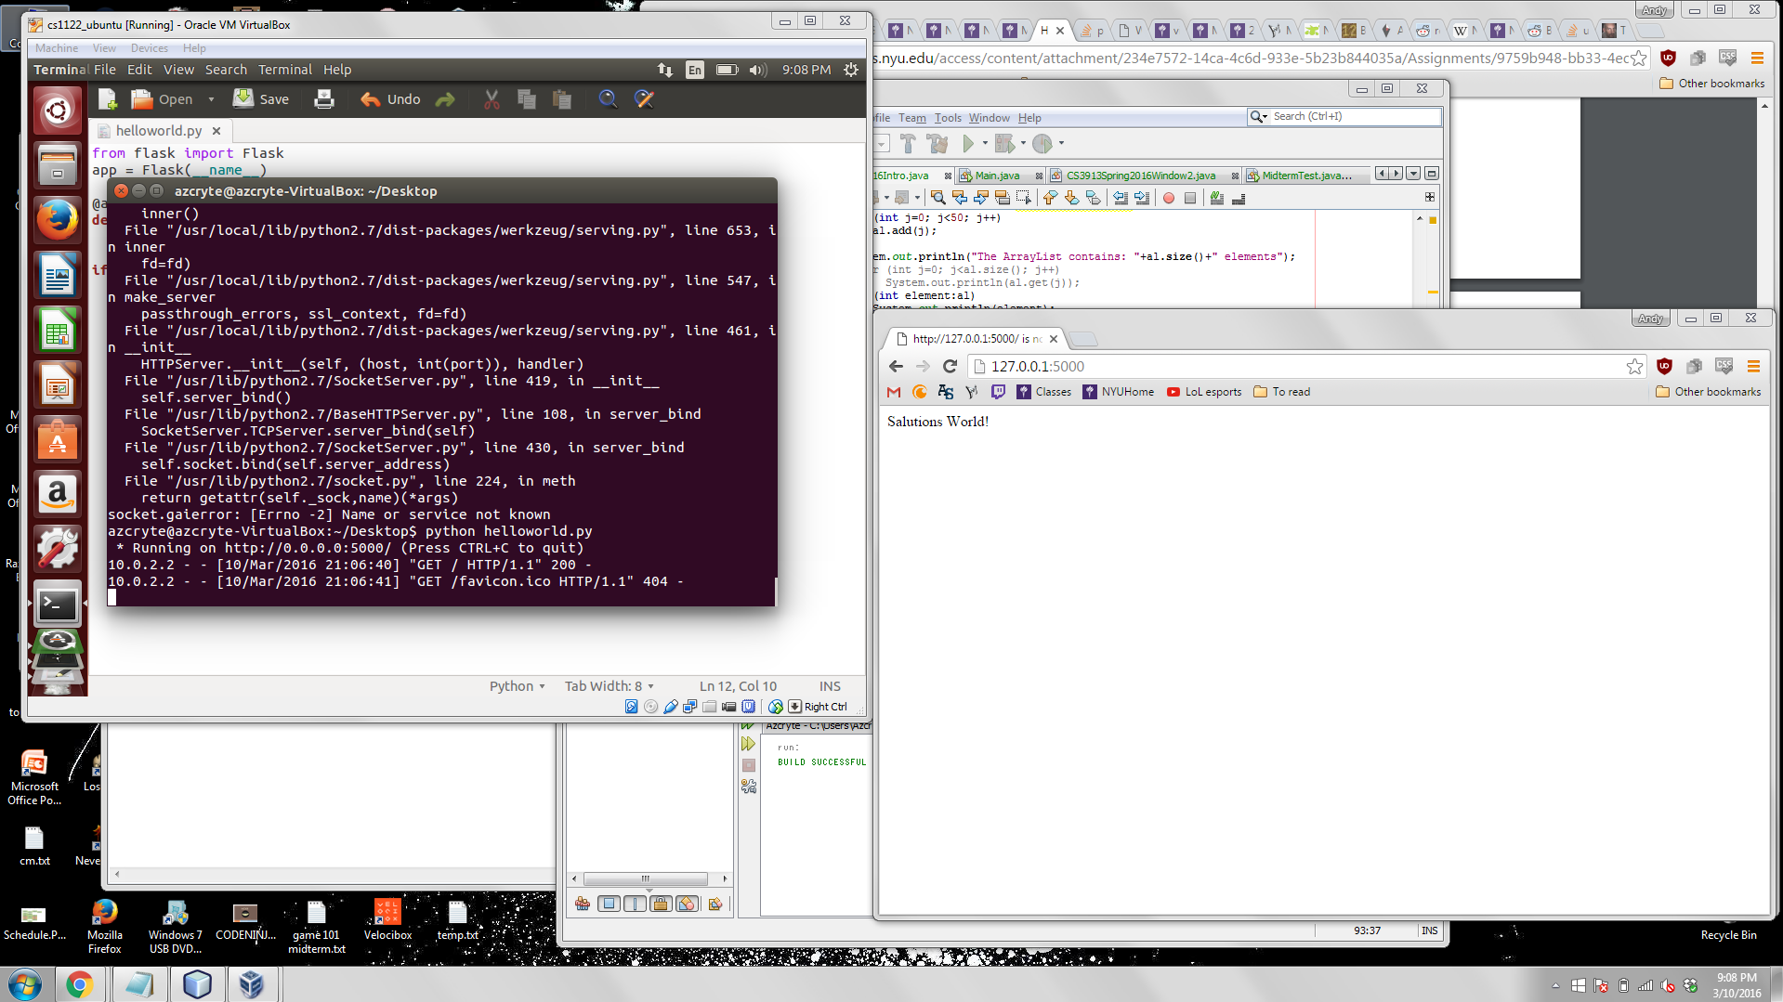

from flask import Flask

app = Flask(__name__)

@app.route(“/”)

def helloworld():

return “Salutations World!”

if __name__ == “__main__”:

app.run(

host=”0.0.0.0”,

port=5000

)

VM Questions

1. A snapshot is a copy of the VM’s disk file at a given time. They are useful to have in order to restore a VM to that particular time in case of system error.
2. sudo apt-get update
3. Yellow Dog Linux uses YUM. Pacman is used in Arch Linux, Frugalware, and DeLi Linux.